**Erase.com & Online Reputation Management Tips for Businesses**

Your digital reputation is fundamental to the success of your business as it is a powerful tool to diversify your web presence and amplify media exposure.

[](https://medium.com/@erase.com?source=post_page---------------------------)

[Aug 22, 2018](https://medium.com/erase-com/online-reputation-management-business-tips-4f86fd494cc5?source=post_page---------------------------) · 3 min read

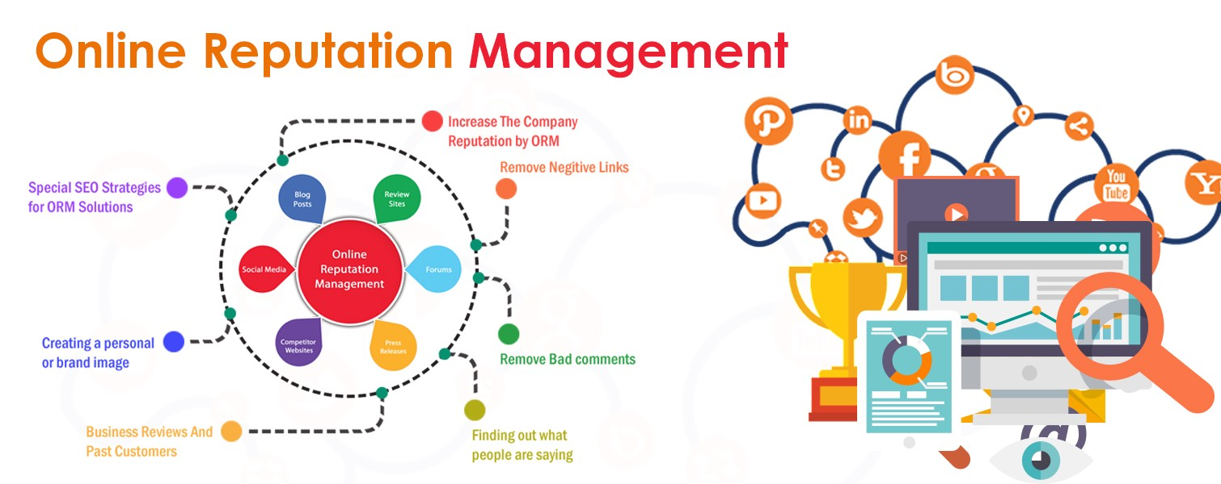

**Why Does Your Online Reputation Matter?**

Creating an online presence is a marketing strategy which helps generate revenue by educating prospective clients of your skills and qualifications. [Erase.com](https://www.erase.com/?source=post_page---------------------------) is a company that specializes in removing negative search results and improving public perception by utilizing authoritative media outlets. By creating authentic and relevant web content, Erase.com’s Positive Reputation Management service helps establish your business as a credible and reliable source of information. Erase.com recommends the following tips to optimize your digital platform:

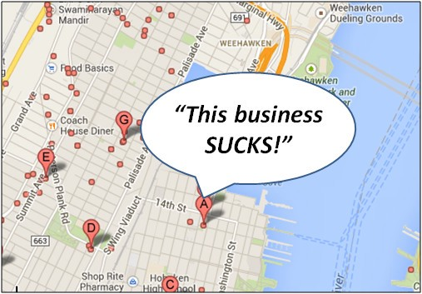**Getting Started — Google Your Business**

With approximately 90% of consumers reading an online review before visiting a business, it is imperative that positive information regarding your product or service appears on your primary page of Google. SEO is a discipline which maximizes the online presence of a web page by implementing various techniques to increase site traffic.

SEO is a permanent investment in your business as it creates awareness by catering to a specific audience. Recognizing that search engine results play an important role in generating a loyal customer base will enable companies to increase their monthly revenue.

**Protect Your Business from Negative Content**

Unfavorable online content such as negative reviews are often a liability and can be detrimental to the growth of your business. However, taking the necessary steps to counteract harmful material, will ensure your company’s image remains protected. According to the professionals at [Erase.com](https://patch.com/new-york/new-york-city/erase-com-how-repair-damaged-online-reputation?source=post_page---------------------------), a significant number of clients are victims of unfair attacks on their reputation. Protecting the integrity of a business has become increasingly difficult due to the accessibility of false information. Ultimately, monitoring business reviews and paying close attention to the competition will allow your company the upper hand.

**Develop Social Media to Engage With Your Audience**

Setting up an Instagram and Twitter account is only the first step in utilizing the benefits of social media platforms. Ongoing development of these accounts can foster a connection with the public and generate a widespread clientele. Engaging with an audience helps build confidence in your business and as a result, customers are more likely to recommend your service to family members and friends.

**Personalize Content to Build Trust**

Creating authentic company content is a powerful online marketing strategy as it enhances visibility through various media outlets. Articles and blog posts are an effective means to showcase your expertise while establishing authority in your industry. Likewise, professional interviews enable your business to share a unique story of yourself and provides a chance to explain what sets you apart from the crowd.

**Take Control**

With new modes of communication, it is essential that your business strategize a coherent plan of action to make the most of their digital resume.

*Erase.com believes that businesses have the power to change the way consumers view their company. Control your narrative by managing digital platforms and recognizing the importance of your online reputation. Go to*[*www.erase.com*](http://www.erase.com/?source=post_page---------------------------)*today and speak with one of our Reputation Specialists who can help with your specific ORM questions.*

Helping to rebuild your online reputation, Erase.com is North America's premiere link removal company. If you have false or negative information about you or your company on the internet, Erase.com is here to assist.

[Digital Marketing](https://medium.com/tag/digital-marketing) [Erase](https://medium.com/tag/erase) [Com](https://medium.com/tag/com) [Reputation Management](https://medium.com/tag/reputation-management) [Online Reputation](https://medium.com/tag/online-reputation)

Thank the xustomer

Mention the business name t=so that it shows up in search enine

Throw marketing in it

Invite customer to do something

Apologize

Throw marketing

Keep it short and don’t mention the name

I came to this restaurant on the recommendation of some friends. And, sadly, it wasn’t how I expected it to be. First thing to notice, the waiters. They were cold toward everyone. I don’t know if it was a bad day but that’s not something to show. Next is the wait. I was sitting for 10 minutes when the waiter finally arrived with the menu and for over an hour when the meal finally arrived. The meal was ok, not worth the wait though. If you want something better, you can find other restaurants close at approximately the same price and with more smiling faces.

Hello! Thank you for your positive review! We are always trying to improve our services at Port Aventura. We are keeping in mind your feedbacks and will try to improve thiss! There is a lot to visit so don’t hesitate to come back! Thx again for your support.